Nama : Nico Syahputra DN

Nim : A11201912292

**Screenshots R studio**

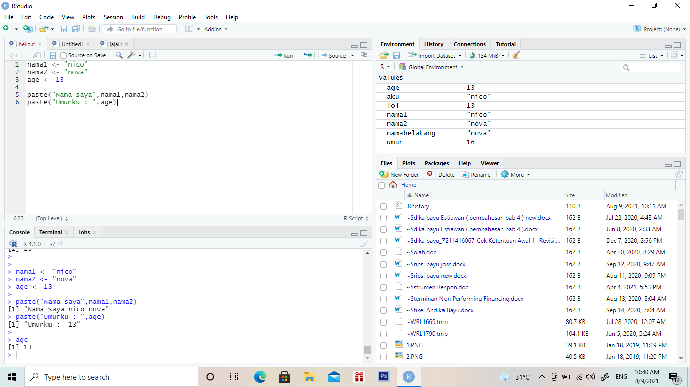

**Screenshots git**

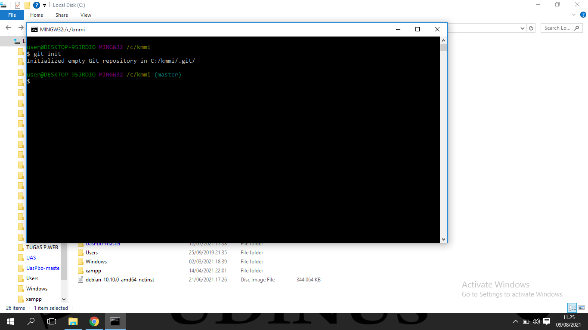

**Push github**

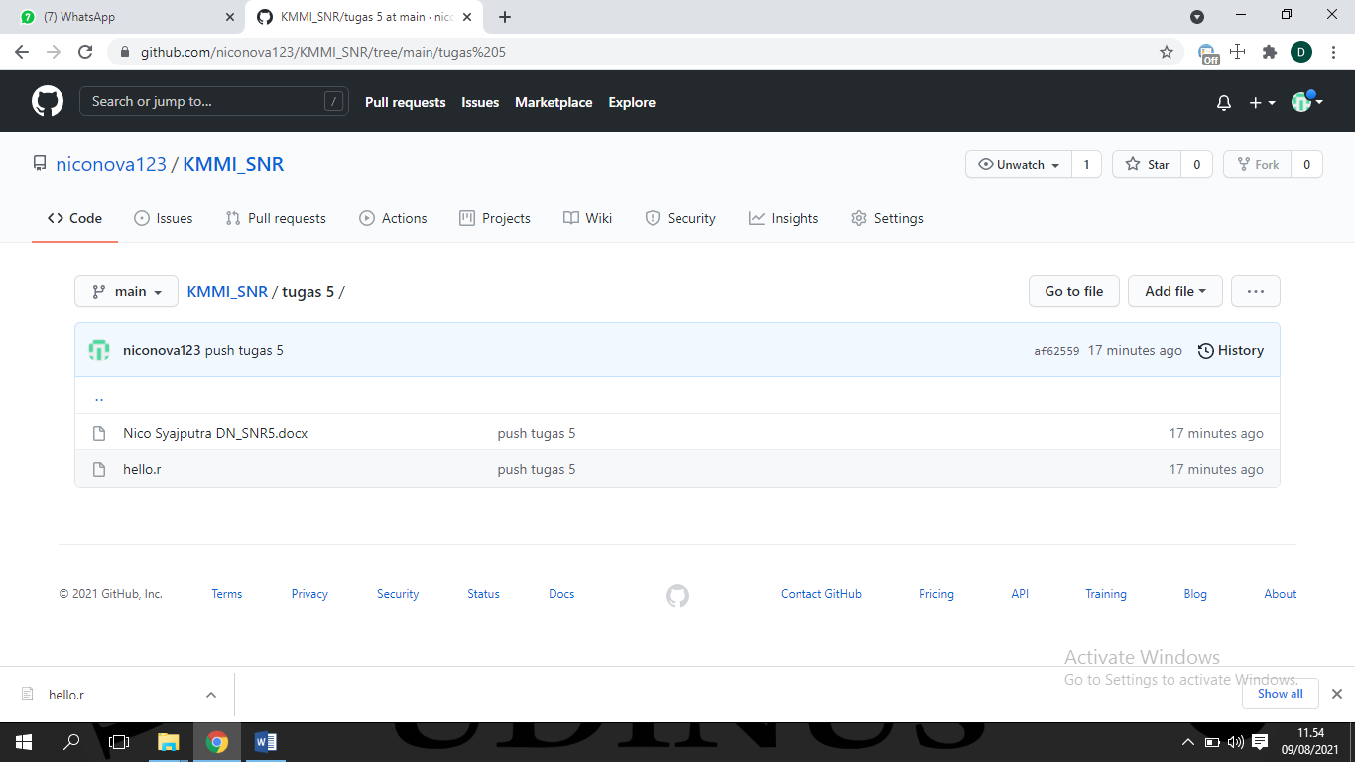

**Screenshots Gephi**

